Diverse migratory portfolios drive inter-annual switching behavior of elk across the Greater Yellowstone Ecosystem

Gabriel R. Zuckerman, Kristin J. Barker, Laura C. Gigliotti, Eric K. Cole, Justin A. Gude, Mark A. Hurley, Matthew J. Kauffman, Daryl Lutz, Daniel R. MacNulty, Eric J. Maichak, Doug McWhirter, Tony W. Mong, Kelly Proffitt, Brandon M. Scurlock, Daniel R. Stahler, Ben Wise, and Arthur D. Middleton

Ecosphere

**Appendix S1**

We performed k-means on scaled and centered data that did not include already identified resident infividuals. We evaluated the plots to identify k such that the within group sum of squared Euclidean distances was minimized, but the between group sum of squared distances was maximized (Lowrey et al. 2020). The optimal value falls between k = 2 and k = 3 (Figure S1).

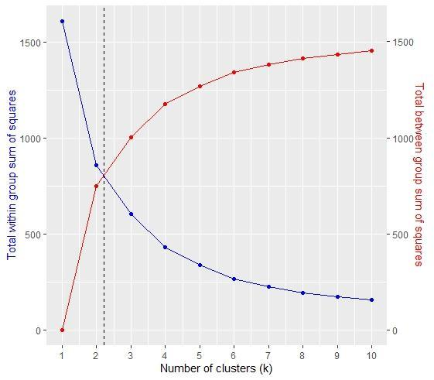

Figure S1. Evaluation of appropriate number of clusters for k-means analysis determined to be between 2 and 3.

Thus, we evaluated both to identify which fit our study system better.

1. 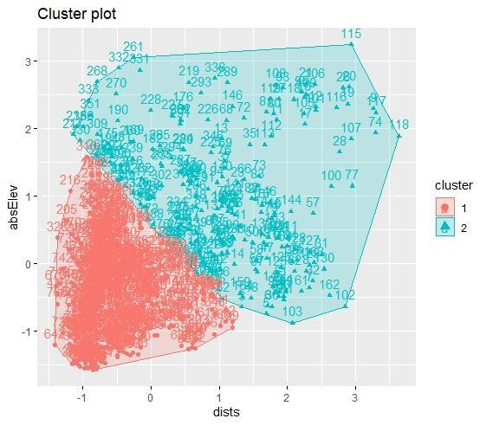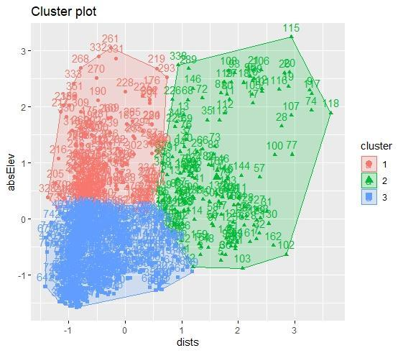 b.

Figure S2.a shows the k-means classification with k = 3 and Figure S2.b shows classification with k = 2.

Given our knowledge of the GYE, we knew that elevational migrants (cluster 1 in Fig. A) were present in the system, thus we opted for k = 3.